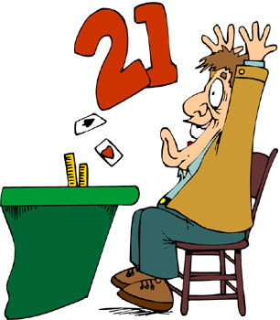
Black Jack assignment.

Create BlackJack application to simulate a simplified version of the game of “21”.

Additional game requirements:
- Print a deck of cards at the beginning of the game
- Shuffle and print the deck again
- Show players cards and card’s total all the time
- Show dealer cards and card’s total when the game is over
- Show dealer cards face down. ( or one card and other face down)
- Display the deck after every round
- Ask if the user would like to play again
- A new deck of card should be introduced if there is less than 5 cards in the current deck at the beginning of the new game
- When calculating totals consider that Ace values 1 or 11.
- Use integers as a card. Use method posted in the website to convert int to Card and int to Value.

OOP application requirements:
- You must use encapsulation, inheritance, and polymorphism.
- You should have at least 3 classes
- You should have at least two static methods ( not counting methods in your testing class)
- You should have at least one static variable ( not counting variables in your testing class)
- You should have an abstract class.

Possible additions.
When you create a dealer randomly pick a dealer’s character or give the user a choice to pick For example, a dealer could be risky, conscious, funny, with ability to count cards, or other.
Create class Joke with a method nextJoke(). Use it in class Funny Player to display unique jokes every time.

The assignment will be mainly evaluated on the Object Oriented Structure.

Table, that explains integers “to card” and “to value” conversion.
Initial array | 0 | 1 | 2 | 3 | 4 | 5 | 6 | 7 | 8 | 9 | 10 | 11 | 12 | 13 | 14 | 15 | 16 | …
Description of a card | K♥ | A♥ | 2♥ | 3♥ | 4♥ | 5♥ | 6♥ | 7♥ | 8♥ | 9♥ | 10♥ | J♥ | Q♥ | K♦ | A♦ | 2♦ | 3♦
Value of a card | 10 | 11 | 2 | 3 | 4 | 5 | 6 | 7 | 8 | 9 | 10 | 10 | 10 | 10 | 11 | 2 | 3

The output of the program should be similar to:
